Gusto-Grove And Dine
Cisco Packet Tracer (Digital Blueprint)


- LOGICAL DESIGN
- Hybrid Topology – Bus +Star
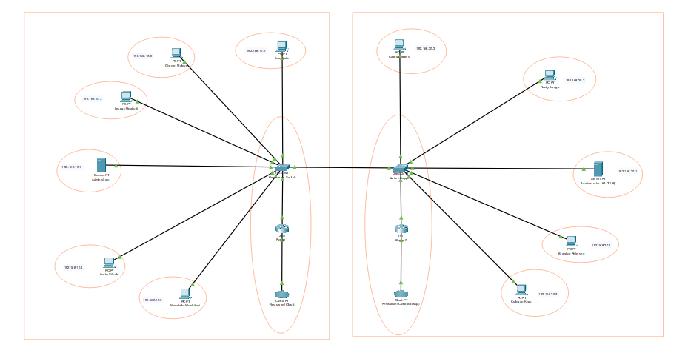
Part 1
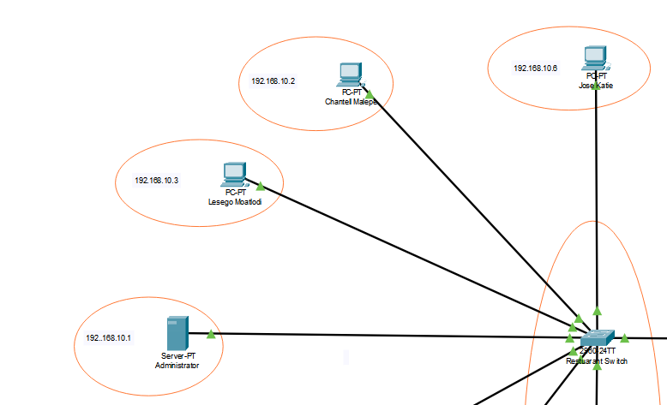

Part 2
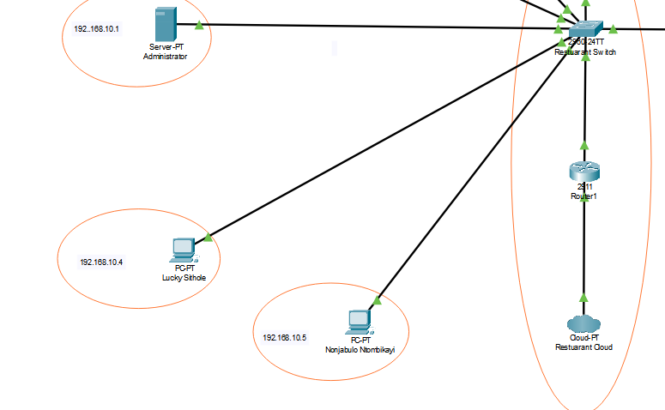
Part 3
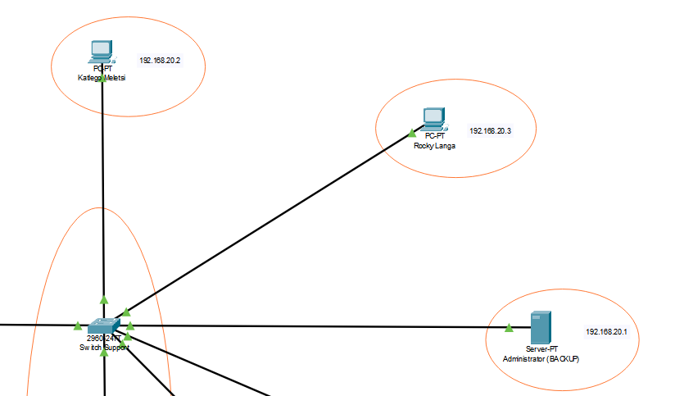

Part 4
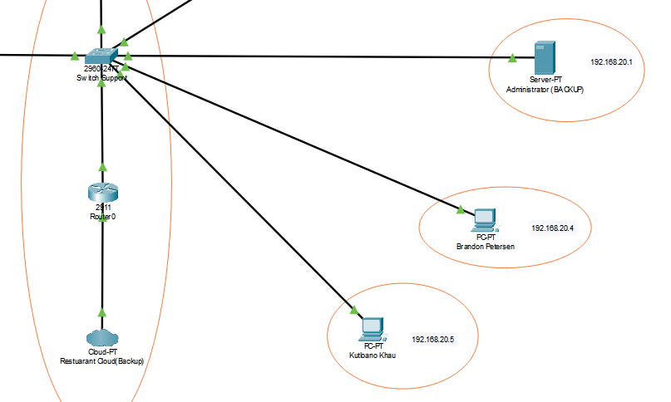

- Configuration
- PCs
- Chantell Malepe
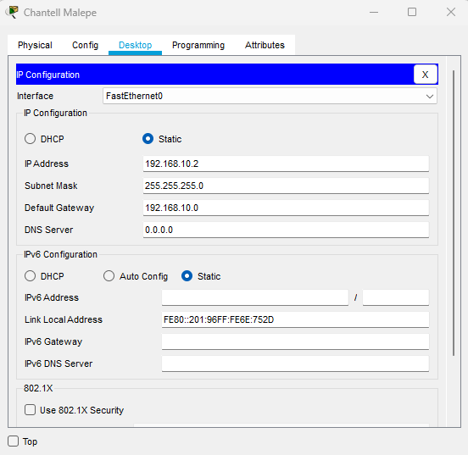
- Jose Katie
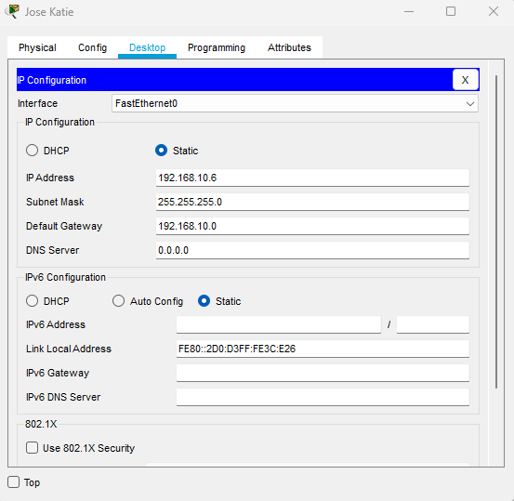

- Katlego Meletsi
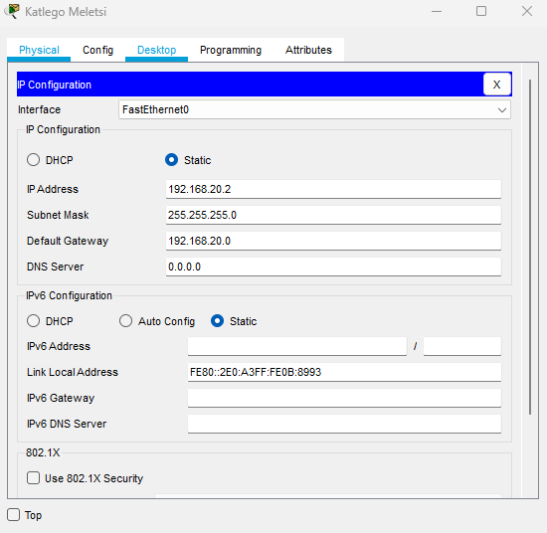
- Kutloano Khau
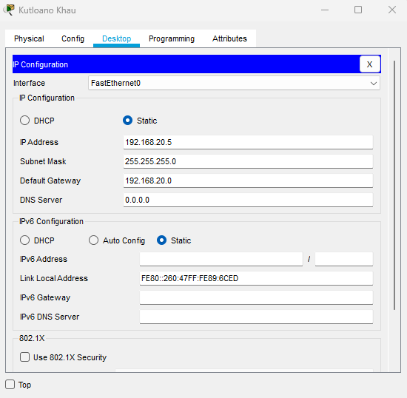

- Lesego Moatlodi
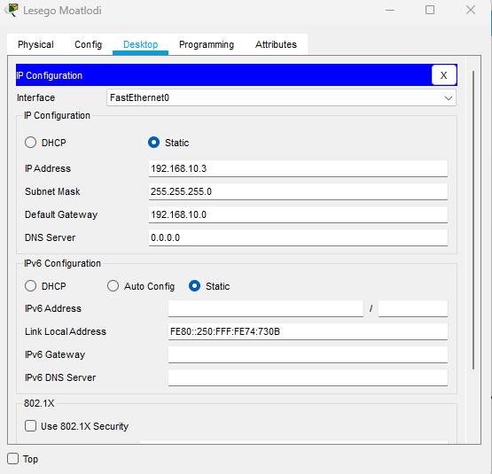
- Lucky Sithole
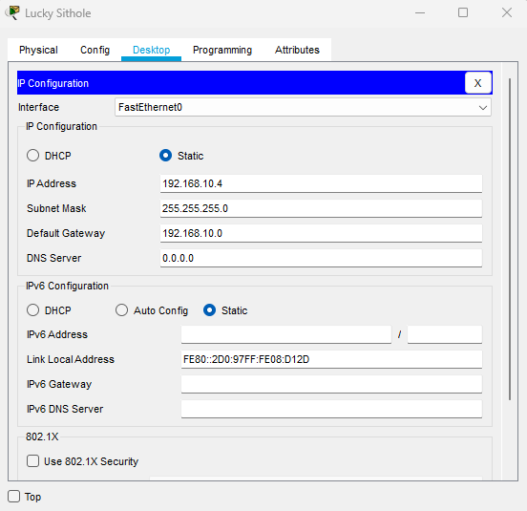

- Nonjabulo Ntombikayi
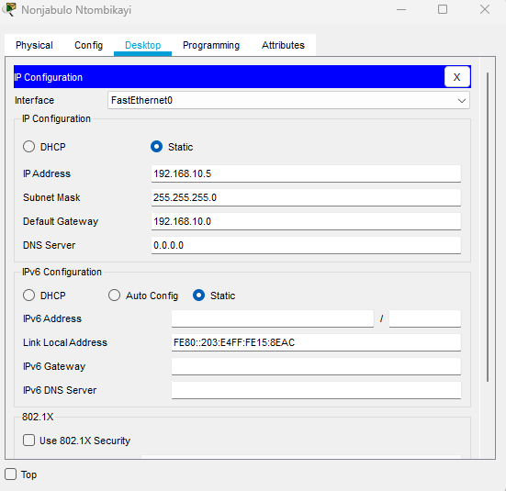
- Rocky Langa
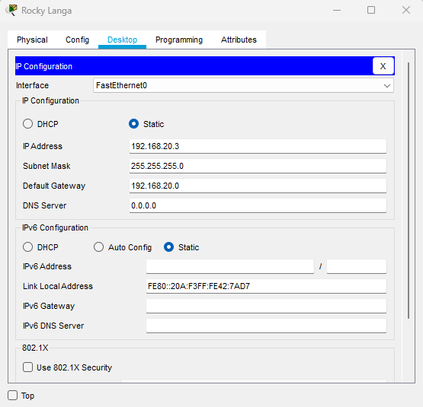

- Brandon Petersen
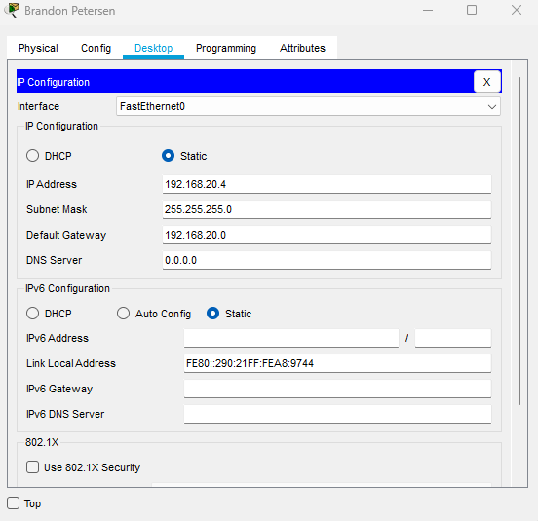
- Routers
- Admin Router
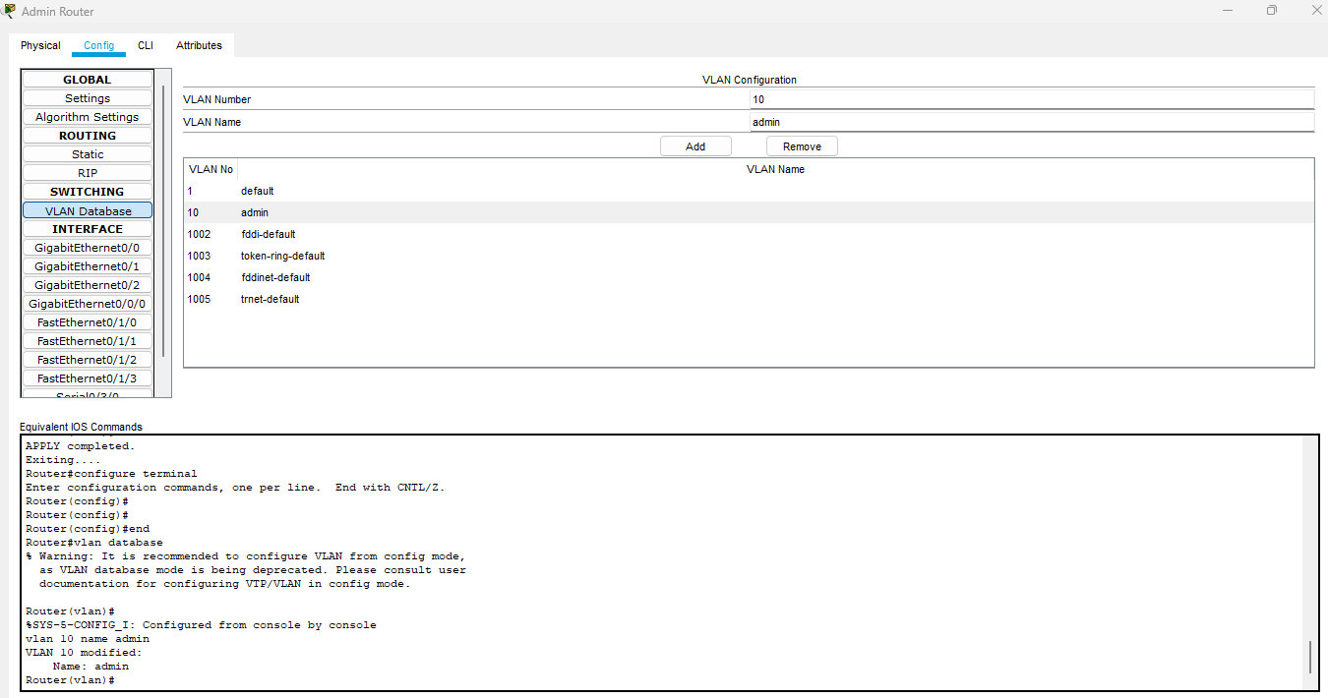
- Backup Router
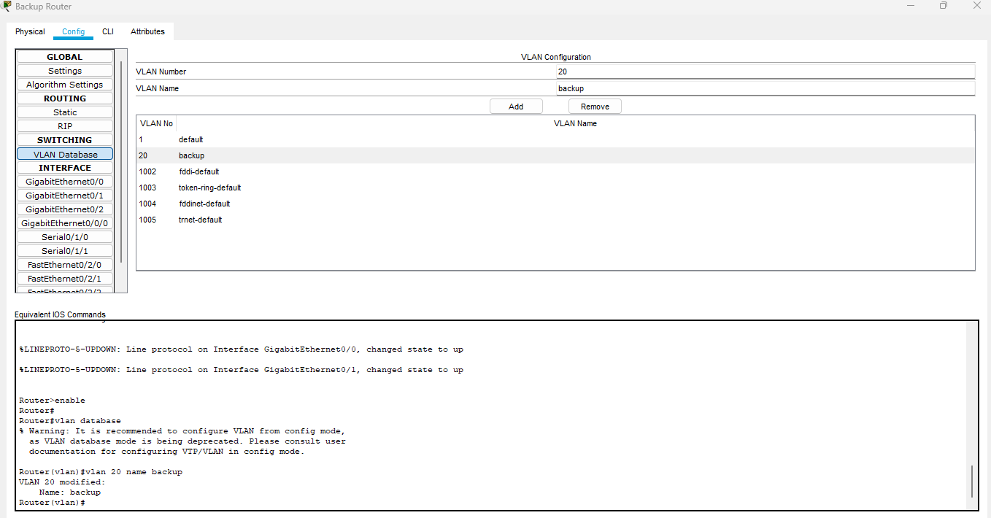

- Server
- Administrator Server
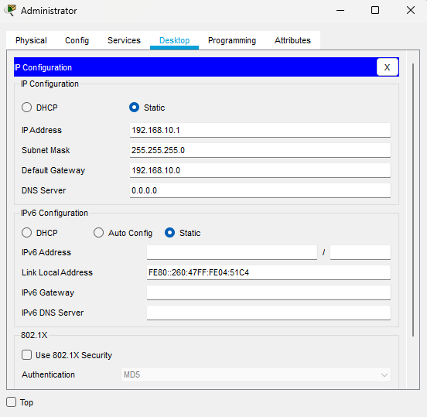
- Backup Server
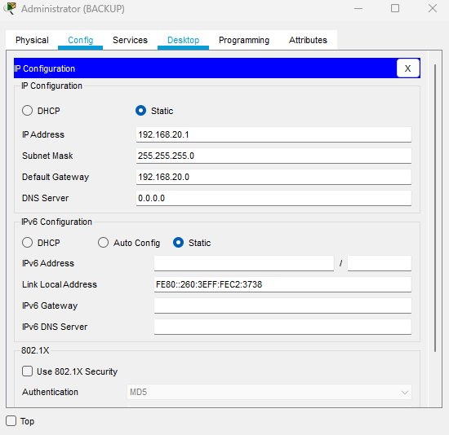
- Switches
- Restaurant Switch
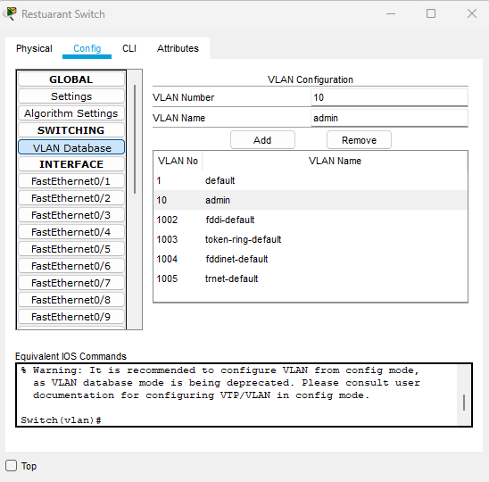
- Switch Support
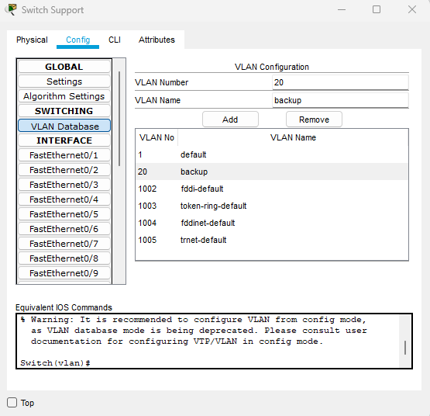
- PHYSICAL DESIGN
- New City
- Johannesburg
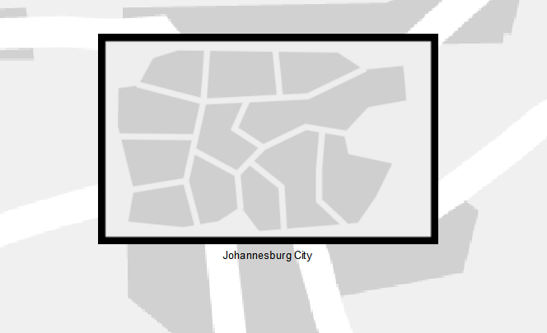
Part 1
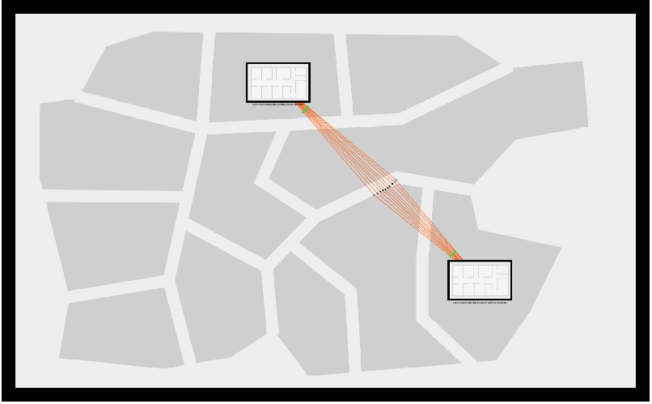

Part 2
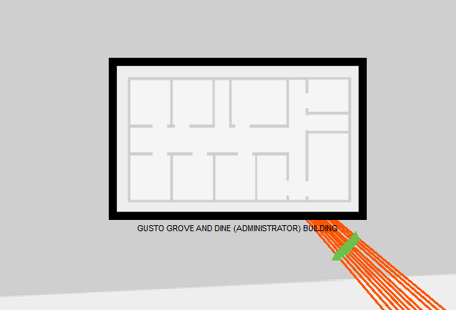
Part 3
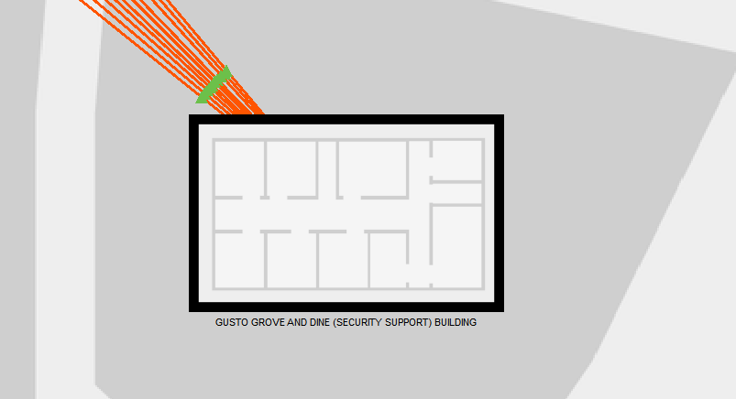

- Office Buildings
GUSTO-GROVE AND DINE (ADMINISTRATOR) BUILDING
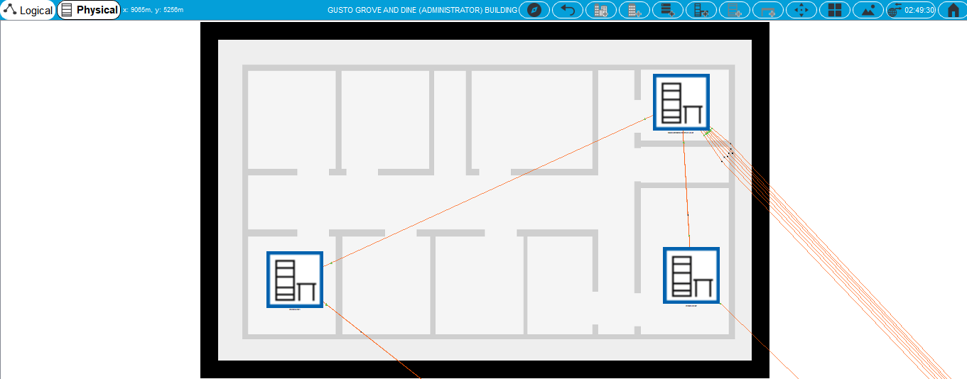

GUSTO-GROVE AND DINE (SECURITY SUPPORT) BUILDING
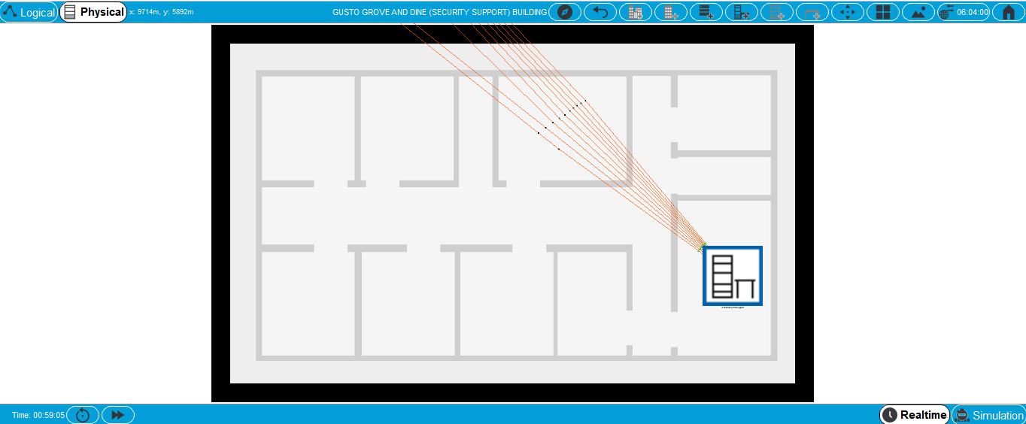

CLOSET SPACES
- ADMIN
Part 1
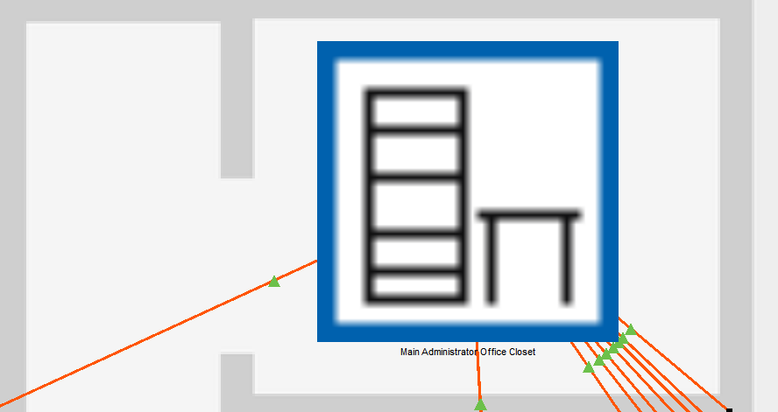
Part 2
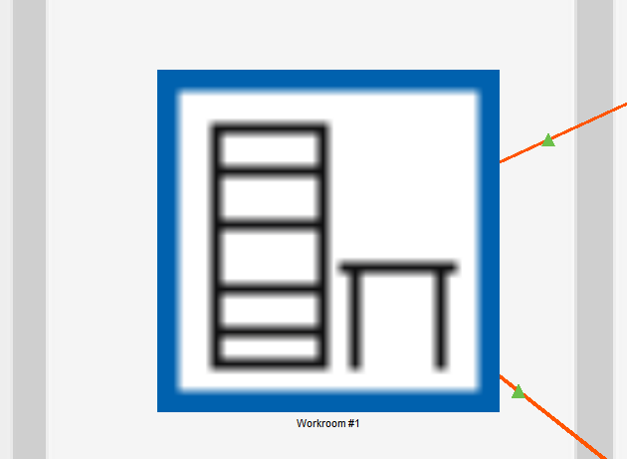
Part 3
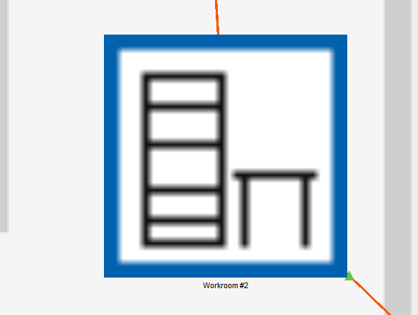

- BACKUP
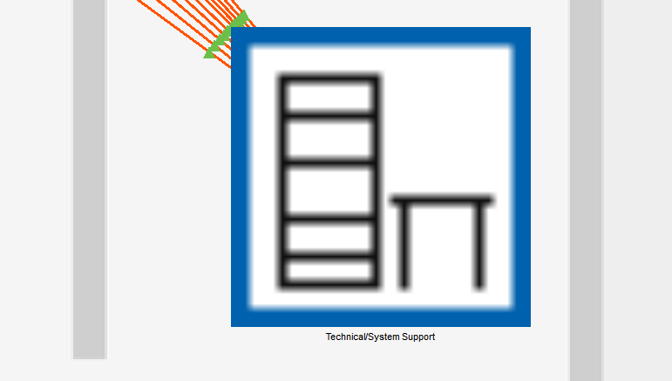
- HARDWARE
- ADMIN
- MAIN ADMINISTRATOR CLOSET STORAGE
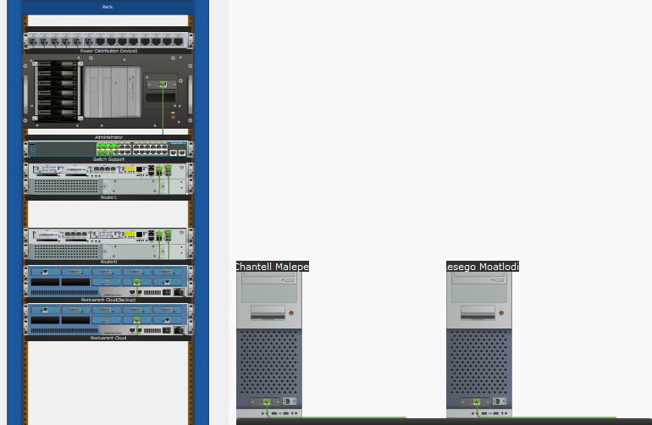
- MAIN ADMINISTRATOR CLOSET STORAGE PART 1
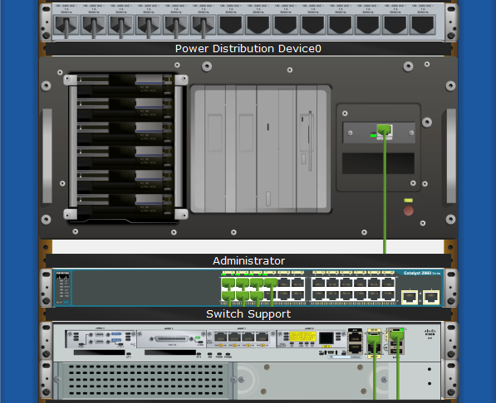

- MAIN ADMINISTRATOR CLOSET STORAGE PART 2
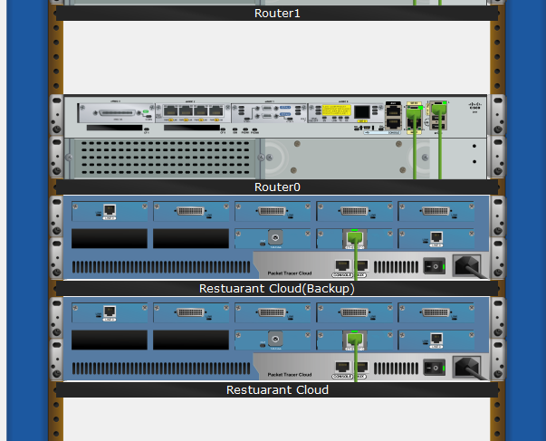
- MAIN ADMINISTRATOR CLOSET STORAGE PCs
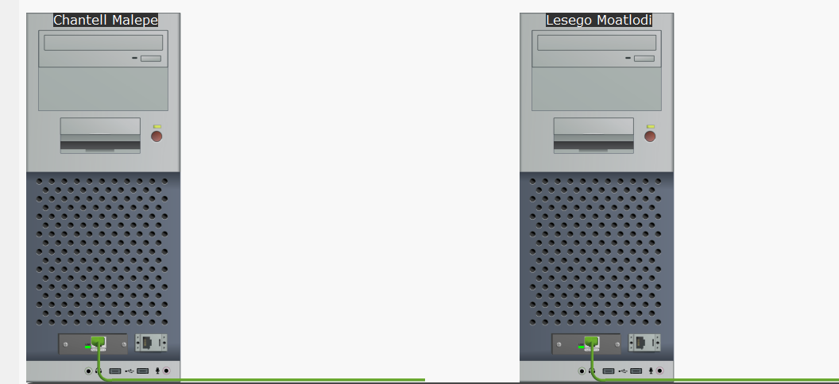

- WORKSTATION #1
PART 1
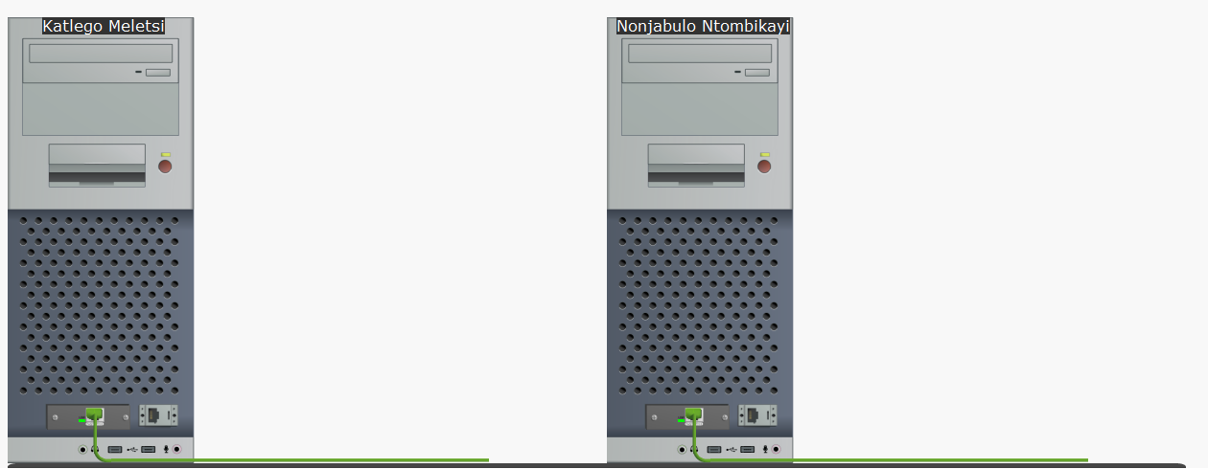
PART 2
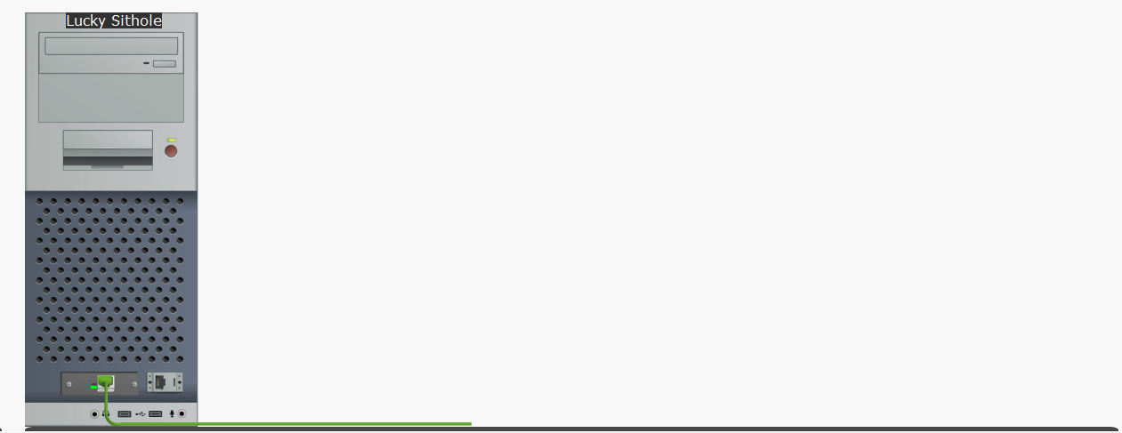

- WORKSTATION #2
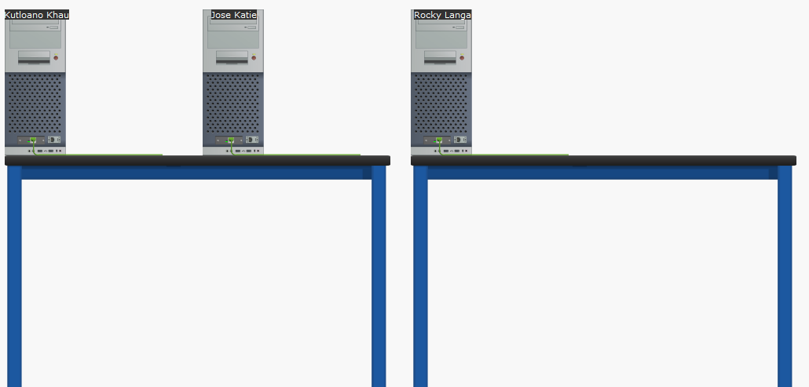
- TECHNICAL/SYSTEM SUPPORT
PC SUPPORT


RACK SUPPORT
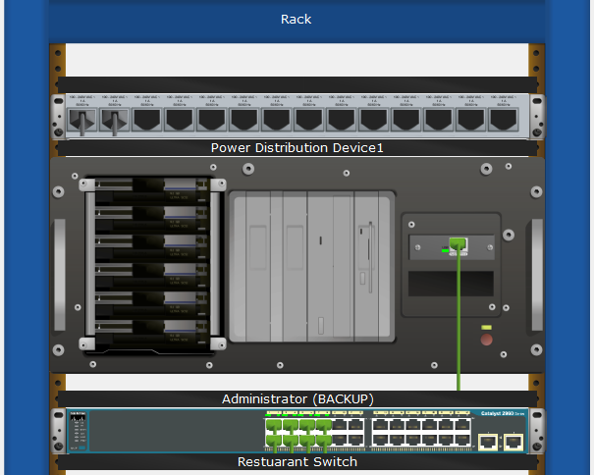

- TESTING PHASE
- PING COMMAND PROMPT
